Atlantic Slave Trade – Projects Name:
This Week’s Standard: Identify the role of Europeans and West Africans in the development of the Atlantic slave trade.

Goal: 5 points

Research a famous person involved in the Underground Railroad.  2 points. | With a partner, play the role of a pro-slavery plantation owner or an anti-slavery citizen and debate your stance.  3 points. | Using the Scholastic Underground Railroad Escape from Slavery site, read the section called “On the Plantation.” Write a diary entry of what it was like to be a slave.  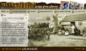  3 points.
Use a picture of a slave ship and draw your own copy.  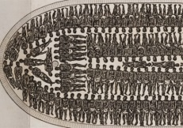  1 point. | Draw a map of the Atlantic Slave Trade  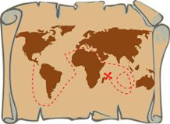  2 points. | Watch the BrainPop video on Slavery and take the quiz.  1 point.

Projects I did:  - Research Famous Person (with _______________)  - Role Play (with _______________________)  - Diary (with _____________________)  - Slave Boat Drawing (with ____________________)  - AST Map (with ______________________)  - Brainpop Quiz (with _______________________) | Project Score  Used Time Wisely ___ / 10  Showed Effort ___ / 20  Correct Information ___ / 20  Total ___ / 50

Atlantic Slave Trade – Notes
This Week’s Standard: Identify the role of Europeans and West Africans in the development of the Atlantic slave trade.

