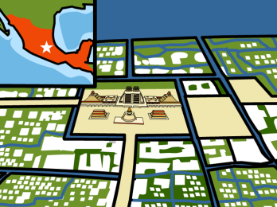**Aztec Civilization**

The Aztec people lived in what is now Mexico in the late 1400’s and early 1500’s.

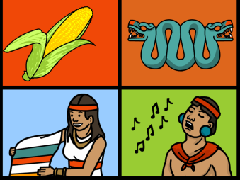

The Aztecs were skilled farmers and craftsmen. They enjoyed trading and the arts, especially singing.

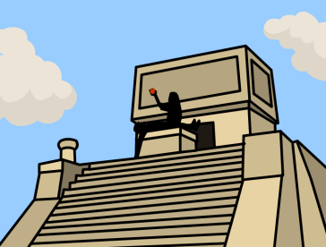

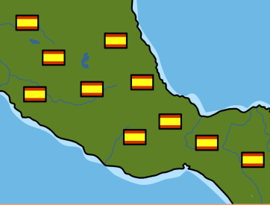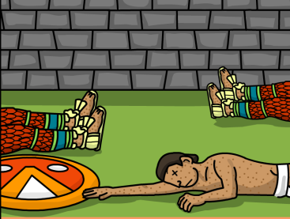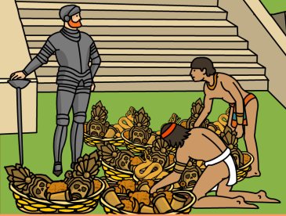

After the fall of the Aztecs, the Spanish set up many settlements in what is now Mexico.

Initially, the Aztecs were able to battle the Spanish and drive them from the city. But, after an outbreak of smallpox, the Spanish were able to easily take over the city.

At first, the Aztec people believed Cortes and his men were gods, and offered them many gifts. However, the people soon realized that Cortes was instead there for conquest.

On an expedition for Spain, Hernan Cortes found the Aztecs in the 1500’s.

The Aztecs believed that their gods had sacrificed themselves for the people, and to repay the gods, the Aztecs often held human sacrifices.