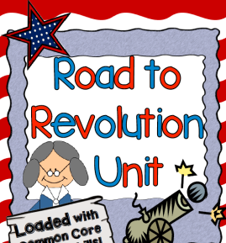
Causes of the American Revolution – Projects
This Week’s Standard: Identify major conflicts between the colonies and England following the Seven Years’ (French and Indian) War; explain how these conflicts led to the American Revolution.

Directions: In this unit, you will represent your understanding of the standard by creating some kind of timeline. Below are the choices. Choose one; this will be the way that you represent ALL of the events in this unit. There are 8 events.

Used Time Wisely ___ / 10  Showed Effort ___ / 20  Correct Information ___ / 20  Total ___ / 50  Project Rubric | 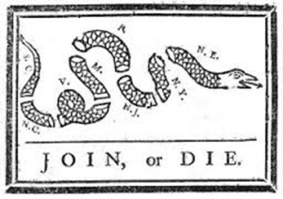  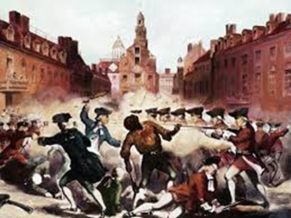

PowerPoint  Make a different PowerPoint slide for each event that leads to the AR. Include the name of the event, a picture, and a summary written in your own words. | Comic Strip  The events that lead to the AR are basically one long story of the colonists getting more and more angry with the British. Represent this story in a comic strip, showing the thoughts and actions of the colonists and the English. | Informative Posters  This option is much like the PowerPoint, but you will be doing it on paper, either with Microsoft Word or by hand.
Video Blog  For each of the events leading to the AR, record yourself talking about that event. Include your ideas on it, how different groups (the English, colonists or Native Americans) are feeling about these events. At the beginning of each video entry, review what you talk about in your last post. | Song  The goal of this unit is for you to talk intelligently about what the causes of the AR were. Some people learn and memorize best through song. Take the events causing the AR and turn them into a song. For each event, give a summary of what happened. | Poem  Dr. Seuss would be so proud of you! Take each event leading up to the AR and turn them into a rhyming poem. Are you a wizard with words?
Puppet Show  In the events leading up to the AR, we keep seeing the same characters, the English and the Colonists. Make a puppet show for each event. Make the puppets with paper and a popsicle stick or a paper bag. Record each “episode” using the OneNote video camera. | String of Events  A timeline is like a long list of things that are connected together. Make a decorative timeline of events leading to the AR and connect them with a string. Include a summary and picture of each event. | Game  In many board games, the object is to get all the way through the path to the other side. Make a board game using events that cause the AR.

