English Colonies – Projects & Notes Name:
This Week’s Standard: Compare and contrast life within the English, French and Spanish colonies in North America.
(Next week we’ll study the French and Spanish colonies)

Goal: 9 points

Make a travel brochure encouraging people to come to the New England, Middle, or Southern Colonies  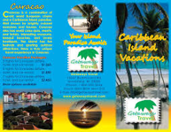  2 points. | Write and perform a commercials advertising one region of colonies.  2 points. | Memorize all 13 colonies and recite them.  3 points.
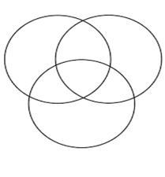  Use a Triple Venn Diagram and compare the three regions of colonies.  3 points. | Find a famous person from one of the 13 colonies to research and make a 5-slide PowerPoint.  2 points. | Make a 3-D model of a colony and label its parts.  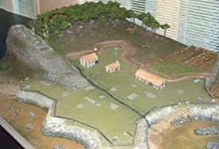  3 points.
Find a map of the 13 colonies online and draw your own.  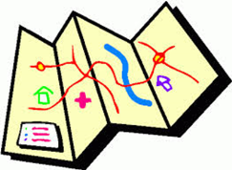  1 point. | 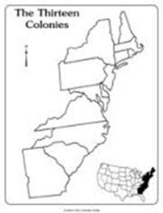  On a blank map, be able to label all 13 colonies.  2 points. | Watch the BrainPop video on The 13 Colonies and take the quiz.  1 point.
OR…create a project of your own. It MUST be approved by Mr. Button.
(There are lots of cool 13 colonies projects online…including a rap!)

Projects I did:  - Travel Brochure (with _______________)  - Commercial (with _______________________)  - Memorize! (alone)  - Triple Venn (with ____________________)  - Famous Person (with ______________________)  - 3D Colony (with ____________________)  - Map (with ____________________)  - Label Blank Map (alone)  - BrainPop Quiz (with _______________________) | Project Score  Used Time Wisely ___ / 10  Showed Effort ___ / 20  Correct Information ___ / 20  Total ___ / 50
English Colonies – Notes
This Week’s Standard: Compare and contrast life within the English, French and Spanish colonies in North America.

