English, French, Spanish Colonies – Projects
This Week’s Standard: Compare and contrast life within the English, French and Spanish colonies in North America.

Higher Level | Select what you think is the most important information about either the French or Spanish colonies and create a PowerPoint | Record yourself for 2 minutes saying everything you know about Spanish or French colonies. Talk the whole time. Your words should be memorized. | Write a persuasive essay on who should have rights to the land in North America.
Lower Level | Record and define important words from the BrainPop video on conquistadors.  sanfelipedelrio_6  district06 | Use page 180 in the book and draw the map of North America that shows the amount of land that Spain, France and England controlled. Use three different colors. Or use the map below. | Make an informative poster that gives information about the notes you took on Spanish OR French colonies (ask Mr. Button for the notes ahead of time). Add pictures and make it look nice.

My name is:  - PowerPoint (with _______________________)  - Record Yourself (with _______________________)  - Persuasive Essay (with _____________________)  - Draw a Map (with _____________________)  - Informative Poster (with ___________________)  - BrainPop (with______________________) | Project Score  Used Time Wisely ___ / 10  Showed Effort ___ / 20  Correct Information ___ / 20  Total ___ / 50
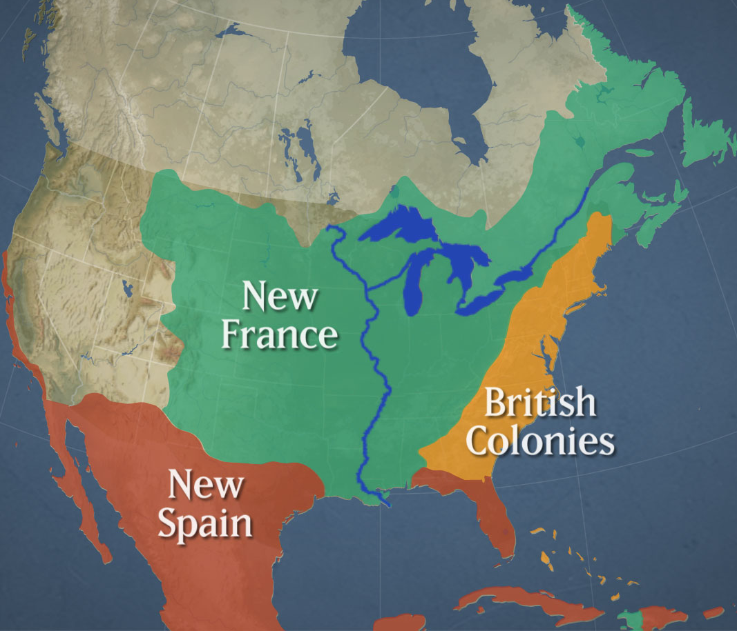
English, French, Spanish Colonies – Notes
This Week’s Standard: Compare and contrast life within the English, French and Spanish colonies in North America.

 | English Colonies | French Colonies | Spanish Colonies
Geography | England settled mostly on the east coast of what is now the Unit States
Economy | English colonies made money in a lot of different ways: growing crops, building ships, fishing, new inventions, trading with Europe
Government | English colonies had the freedom to set up their own government, but were “watched” by the King of England
Religion | Most were not Catholic. Many different religions were represented in the colonies (for example, Puritans and Quakers)
Relations with the Natives | English colonists were friendly with the natives at first. Then colonists got greedy and tried to take more land. Eventually, English colonists and natives had a big war.
Vocabulary Words

