Patriots vs. Loyalists
???
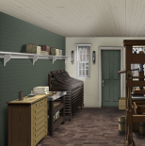
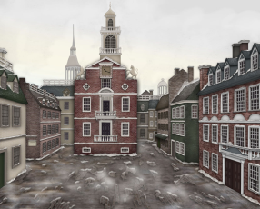
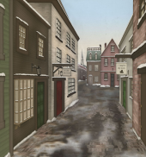
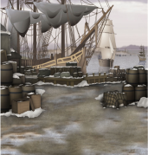
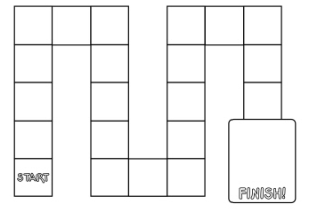
Event
Directions: Roll the number cube and answer a ??? card. If you answer the question correctly, you ge to move the number of spaces shown on the number cube. If you land on a LANDMARK square, you get to immediately draw an EVENT card and follow the directions given. The first group to make it to King Street gathers more people to its cause!

????  In what year was the Boston Massacre? | ????  What is an apprentice? | ????  Who defending the British Soldiers and later became the second president? | Event  You accidentally asked a redcoat if he’d like to buy a copy of the Boston Gazette. Go back 2 spaces. | Event  Your shop was vandalized by the Sons of Liberty because you sell imported goods. Go back 3 spaces.

