Geography of the 13 Colonies – Projects Name: _________________________
This Week’s Standards:
Locate and identify the physical and human characteristics of places in the North American colonies.
Explain how geographic factors affected land use in the North American colonies.

Complete the “Create a Colonist” packet where you will make up a fictional colonist and answer questions about him/her. You’ll also add one more question: ‘how did your colonist use the physical features of the land?’  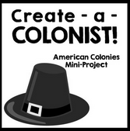 | Draw a very detailed map of the 13 colonies, its major cities, its major bodies of water (rivers, bays and oceans), and its mountains.  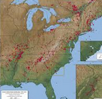 | Research the elevation of five important cities in the 13 colonies. Find the elevation of Austin and compare all six elevations in a graph using Microsoft Excel (Mr. Button will show you how to use it).  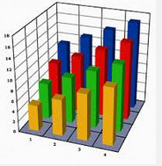
Create a piece of art (songs, poems, stories, drawings, paintings, raps, clay) about the physical characteristics of the 13 colonies and how the colonists used them. | Create a fictional newspaper or news broadcast with news from one of the 13 colonies. Include the weather report, current events, and one other story (sports, or famous people, etc.). Use what you know about that colony’s climate to make up the weather report. Use the textbook or another source to write the current events. The last section will be fictional. | Make a timeline of important events in the 13 colonies that happened before the Revolutionary War in 1775.  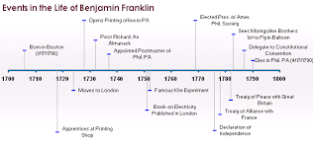

The project I did was…  - Create a Colonist  - Detailed Map  - Elevation Graph  - Art  - Newspaper or Broadcast  - Timeline | Project Score  Used Time Wisely ___ / 10  Showed Effort ___ / 20  Correct Information ___ / 20  Total ___ / 50

Geography of the 13 Colonies – Map Name: _________________________
This Week’s Standards:
Locate and identify the physical and human characteristics of places in the North American colonies.
Explain how geographic factors affected land use in the North American colonies.

Directions: Label the physical landforms and major cities on the map below. We will be talking about them all week.

