How to be a Movie Star

An in-depth study.

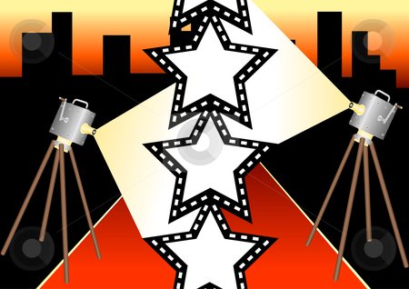

By Brandon Button

Introduction
Each day, millions and millions of people around the world wonder what it’s like to be a movie star. We are fascinated with Hollywood. Celebrities have millions of followers on Twitter. They are swarmed by fans everywhere they go, and they live in the most expensive houses and drive the most expensive cars.
Have you ever wanted to be a movie star? It may be easier than you think. Just follow the simple steps below.

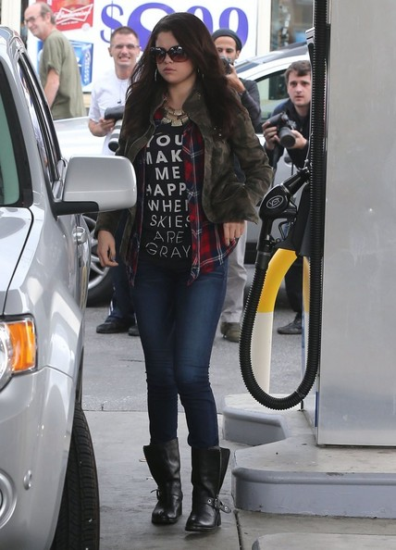

Stay Away From Bad Roles
We’ve all heard it. Those infamous words: “that role will ruin her career.”
There’s a lot of pressure when it comes to being a movie star. Your fans expect a lot from you, your agent expects a lot from you, HOLLYWOOD expects a lot from you. When you begin to feel yourself rising in stardom, you have permission to begin being a little more selective in your roles. You don’t have to say ‘yes’ to the role of “girl on street” or “dead body #4.” Instead, demand that your character have at least a name.
Now, no one can predict a box office flop. In fact, if producers were able to tell that their movie was going to bite the big one, it might actually save a lot of time and money. But let me give you a little piece of advice: stay away from any script that involves vampires, aliens, or extended time on a plane. Trust me. No one has ever broken into Hollywood because of a riveting performance as a scare flight attendant or teenaged girl in a vampire/werewolf love triangle.
