Interactions and Consequences – Projects
This Week’s Standard: Describe early interactions between indigenous peoples, Europeans and Africans, including the Columbian Exchange; identify the consequences of those interactions on the three groups.

Make a Word Wall with the definition and pictures for the vocabulary words: indigenous people, Columbian Exchange, interactions, consequences.  3 points. | Write a short play about a miscommunication and greed between two strangers which results in an argument.  3 points. | 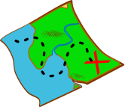  Find a map of the Columbian Exchange online or in a textbook. Draw your own and add color.  2 points.
One of the challenges between the Europeans and indigenous people was a language barrier. Speak in a language other than English for an entire day. Then, write about your experience including the challenges you faced.  3 points. | Make a board game involving the Columbian Exchange.  2 points.  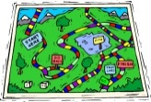 | Make a creation that shows the injustice of slavery (in other words, why slavery was wrong). Your creation can be a song (or rap), painting, poem, or anything else creative. Your creation should make people think about slavery and feel emotion.  2 points.
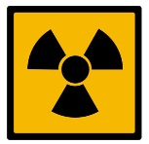  Research the recent Ebola outbreak in Africa. Compare that with the diseases that the Europeans brought to the indigenous people of North America.  2 points. | Calculate how fast ships were able to travel using the distance and time formula. Show your calculations.  1 point. | Complete the Brainpop Quiz on the Columbian Exchange. Show Mr. Button your score when you’re done.  1 point.

My name is:  - Word Wall (with _______________________)  - Play (with _______________________)  - Map of the C.E. (with _____________________)  - I spoke in a different language and then wrote about it.  - Board Game (with _____________________)  - Slavery Creation (with ______________________)  - Ebola Comparison (with ____________________)  - Calculations (with _______________________)  - Brainpop Quiz (with _______________________) | Project Score  Used Time Wisely ___ / 10  Showed Effort ___ / 20  Correct Information ___ / 20  Total ___ / 50

Interactions and Consequences – Notes
This Week’s Standard: Describe early interactions between indigenous peoples, Europeans and Africans, including the Columbian Exchange; identify the consequences of those interactions on the three groups.

