Must-Do Stuff
Week of November 3rd Name

MONDO Job
- Finish your MONDO Job
Words Their Way
- Finish WTW Job each day
  - Monday
  - Tuesday
  - Wednesday
  - Thursday
Read to Self
- 25 minutes
  - 2 inner voices
  - 1 vocabulary words
- 25 minutes
  - 2 inner voices
  - 1 vocabulary words
NewsELA Article
- Find and read one article
  - Make sure it has a quiz
  - Choose your good-fit Lexile Level
Optional Stuff
IXL
- F1 & H1 – 10 minutes
- F1 & H1 – 10 minutes
Extra Read to Self
- 25 minutes
  - 2 inner voices
  - 1 vocabulary words
Read to Someone
- Tuesday – 25 minutes
  - Read one sentence at a time.
  - Check comprehension with Read-to-Self bookmarks
- Thursday – 25 minutes
  - Read one sentence at a time.
  - Check comprehension with Read-to-Self bookmarks

Work on Writing
- Monday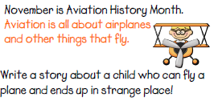

- Tuesday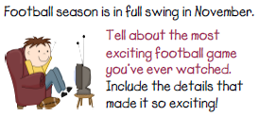

- Wednesday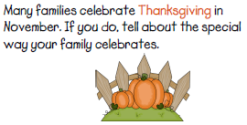

- Thursday 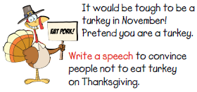

- Friday 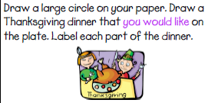
Expanding Vocabulary
- Notice. Find a word anywhere (in a book, on IXL, on the wall, anywhere) that you don’t quite know or understand yet. Write that word down in the Notice column.
- Guess. Good readers can make good guesses about what a word means by using the clues around it. Use the clues around the vocabulary word make a guess about what it could mean. Write it in the Guess column.
- Check. Good readers also have the skills to look up a word and find out what it means. My favorite online dictionary is www.yourdictionary.com. Some words are made up and you can’t find them in the dictionary. Some words are names of people or places and you probably won’t find those in the dictionary either. If there is a word that is not in the dictionary, you may write a Post-it note and stick it to Mr. Button. You will not receive a You Owe Me Time card if you’re asking me about a word. Do it quickly, though, and get back to work.
Once you find out what the word means, write it in the Check column. Now you can use that word when you speak or write. Your friends and teachers will know what a good reader you are!!!
Notice | Guess | Check
At the end of the week, Friday, turn this paper in to Mr. Button so he can see all the awesome work you’ve done expanding your vocabulary!!!

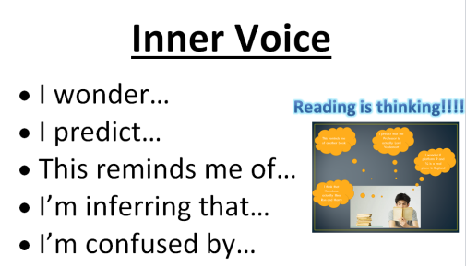
Inner Voice
Write your Inner Voices here so Mr. Button can read them at the end of the week.

What I Did This Week During Reading

Monday | Tuesday | Wednesday |  | Thursday |  | Friday
Reading Part 1  Words Their Way and  Library Time | Reading Part 1 | Reading Part 1 | Reading Part 1 |  | Reading Part 1
Reading Part 2 | Reading Part 2 | Reading Part 2 | Reading Part 2 |  | Reading Part 2  Early Release Day – No Reading Part 2

