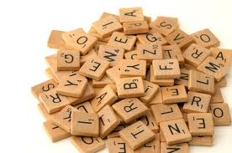Machine generated alternative text: Scrabble
*Remember to add up the total points for each word.
— - 
- I __
B
-
C
N
3
.1.
!
I
H
4
A
T
I
—
1 1
1

Scrabble -4

Friday, January 03, 2014

7:34 AM

|  |  |
| --- | --- |
| Word | Score |

|  |  |
| --- | --- |
|  |  |
|  |  |
|  |  |
|  |  |
|  |  |
|  |  |
|  |  |
|  |  |
|  |  |
|  |  |
|  |  |
|  |  |
|  |  |

Machine generated alternative text: 4 - 12÷ words cul over four letters long
3 - 12+ words most over 3 letters long
2 - 12 + words
1- lessthon 12 words